# INTRODUCTION

## About GO-JEK

GO-JEK has officially expanded its market to Southeast Asia including Vietnam with new technology investment in GO-VIET. One of the future promises that GO-VIET will be the provider of ride-hailing, logistics and digital payments services on the battle with Grab.

GO-JEK was founded in 2010 with its predecessor - the company providing motorbike taxi service on the mobile platform, also known as ride-hailing technology. GO-JEK not only offers ride-hailing services but instead dozens of other services can be deployed through this application. GO-JEK offers a wide range of services such as 2-wheel and 4-wheel mobile vehicles, shopping, housekeeping, health care and car repair services. This is what Grab and Uber in Vietnam does not have and may be a good point if GO-JEK start running in this country.

Reported on 2018: The application of GO-JEK company has been downloaded more than 60 million times in Indonesia, according to a press release last month. GO-JEK has over 900,000 registered drivers in the country and facilitates over 100 million transactions a month.

## About GO-VIET

GO-VIET is proud to be a strategic partner of GO-JEK, providing multi-service applications with four-wheel and two-wheel drive transportation solutions, ordering, delivery and many other services. Serving the daily needs of Vietnamese users.

With GO-JEK's advanced world technology platform, GO-VIET aims to improve the quality of life for our users and create value for our partners and communities.

Besides to the riding service, goods delivery, shopping, GO-VIET is the solution to help you handle daily needs easily, conveniently and quickly.

GO-VIET cooperates with thousands of driver partners, restaurant partners and other partners in Viet Nam to bring you a comfortable experience on every service. GO-VIET's products are aimed at facilitating users and solving social problems such as employment, income and business development of small and medium enterprises.

# EXISTING IT SERVICE SCOPE

GO-VIET is an application for ride-hailing, online shipping, food delivery, billing and daily services. At the moment, GO-JEK invests more than US $ 500 million in 4 markets in South East Asia including Vietnam, Singapore, Thailand, Philippines. With that amount of money, GO-VIET in Vietnam is the biggest competitor of Grab in Vietnam, when it owns more than 95% of the market ride-hailing technology.

## Current service

GO-VIET is currently providing a variety of mobile transporting and shipping services including:

* **GO-RIDE**

GO-BIKE is a motorcycle drive technology service of GO-VIET has just launched, application will connect motorbike drivers with customer using GO-VIET application to solve the traveling needs of customer as well as increase additional income for the driver.

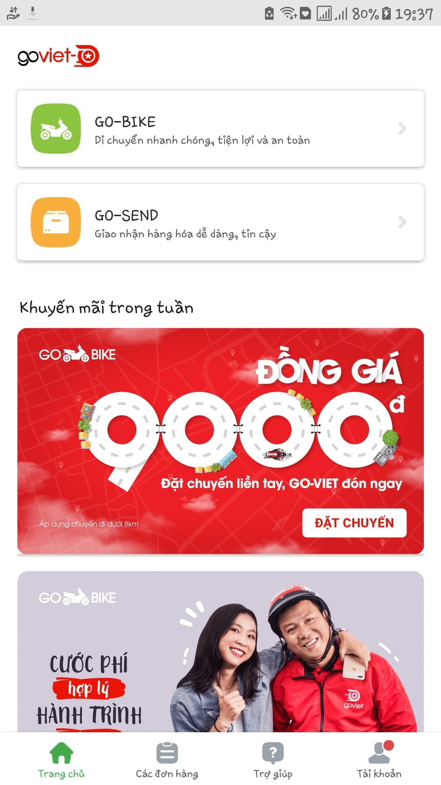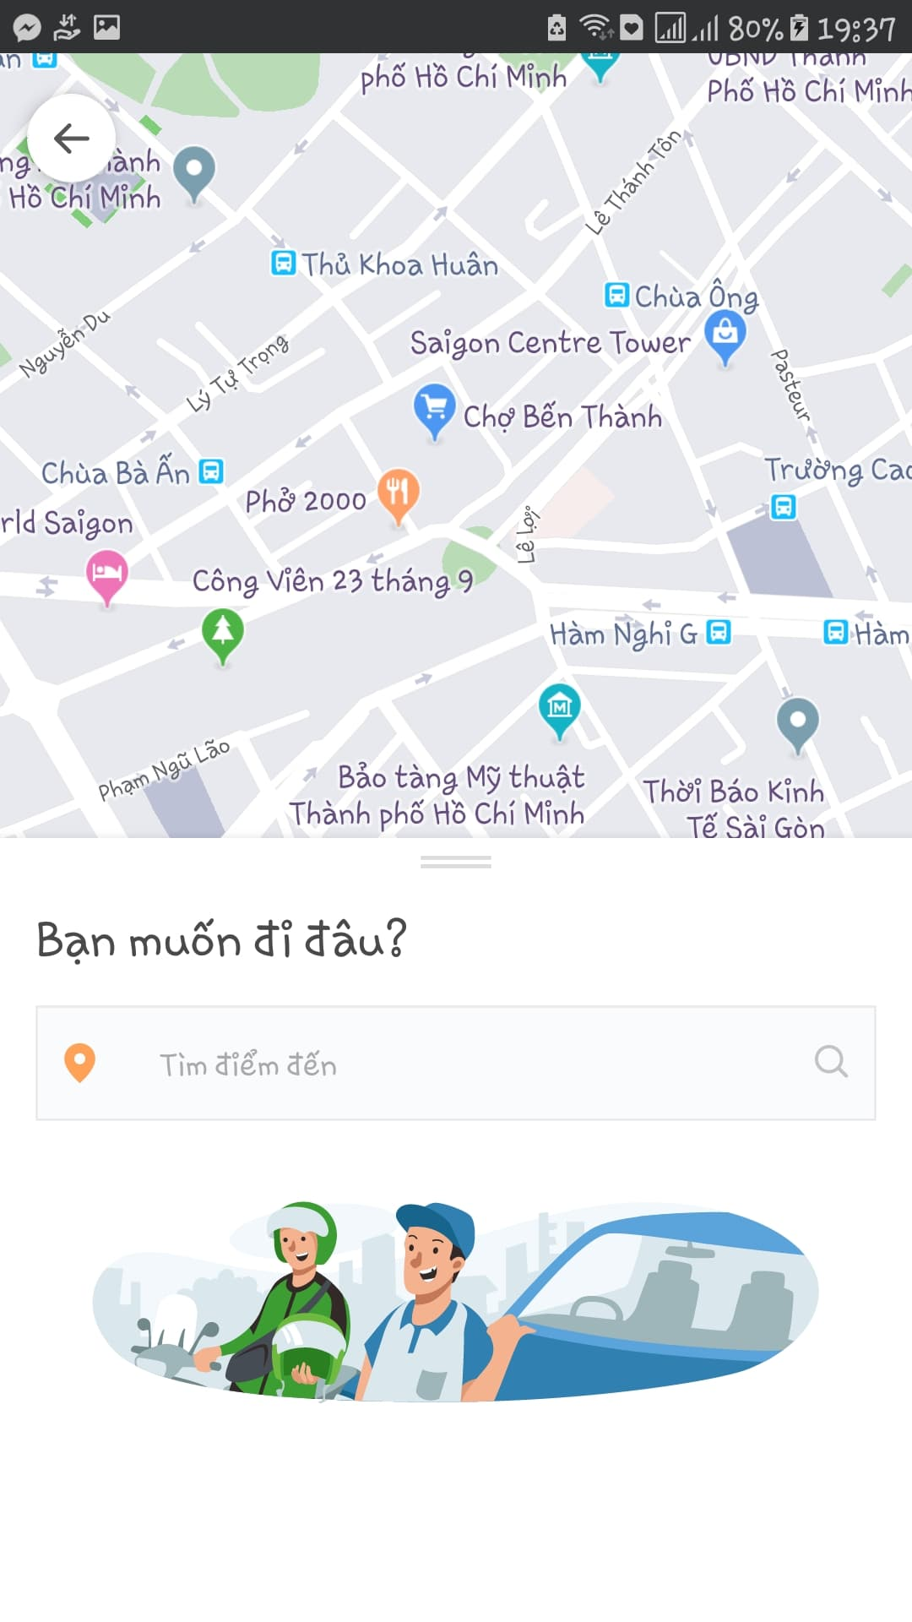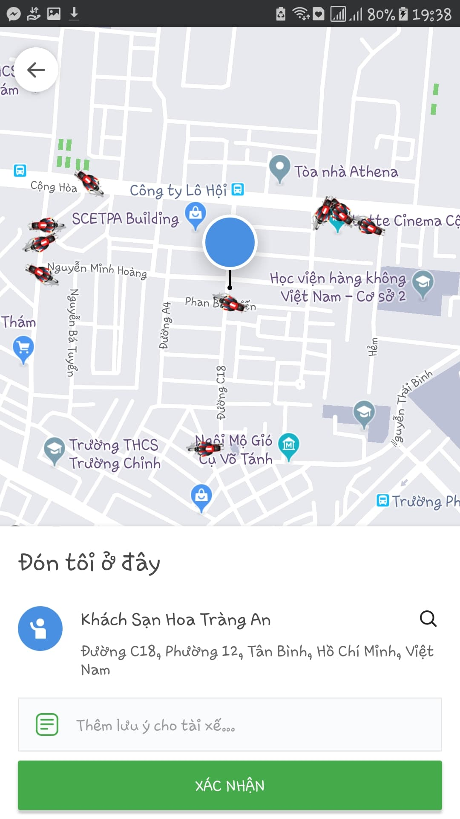

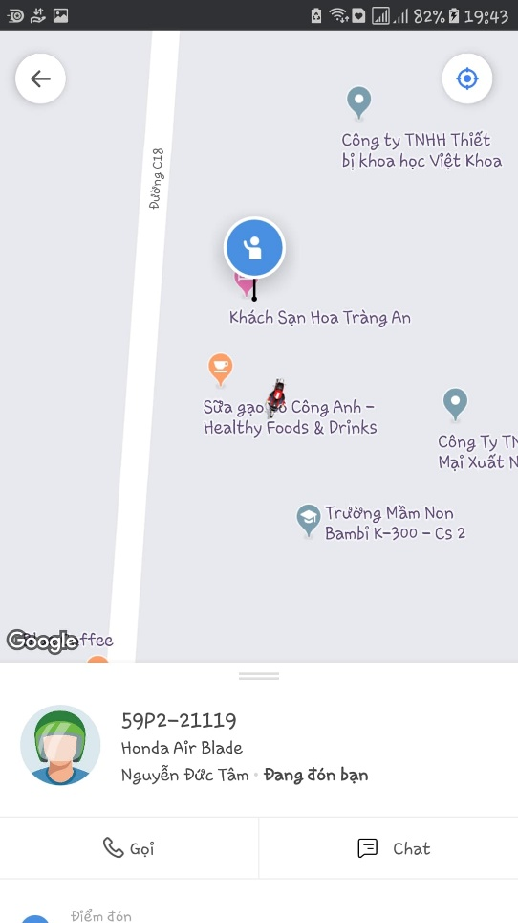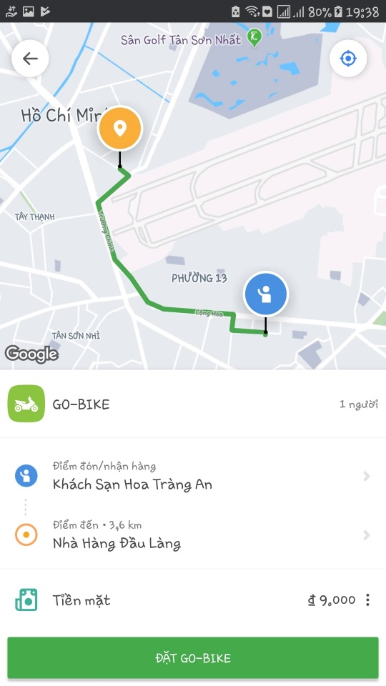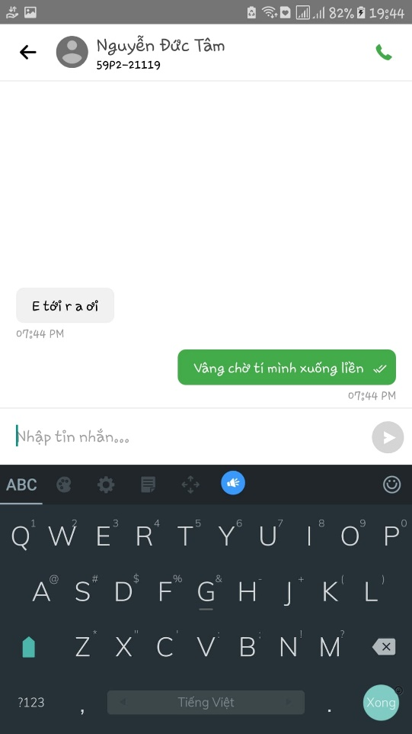

* **GO-SEND**

GO-SEND is a GO-VIET motorbike delivery service for customer who wish to book the delivery. You can easily deliver letters, goods, gifts, products safely, quickly and economically. Commodities will be delivered by GO-BIKE drivers of GO-VIET to increase driver's income as well as cost savings for customer.

When using GO-BIKE and GO-SEND, customers don’t have to worry about the distance, price or time because even it’s far or near, day or night, dry or wet, GO-Driver will happy to delivery their customer’s goods to the location. That’s the strong side of GO-VIET which made this company become the 1st competitor of Grab nowadays.

# GO-CLEAN

As GO-VIET expanding its business, GO-CLEAN will be the next service in Vietnam. GO-CLEAN, with the moto “***CLEANING YOUR HOME IS NO LONGER A CHORE***”, will give customers the most professional cleaning service at anytime and anywhere.

## About GO-CLEAN

GO-CLEAN is an app-based professional cleaning service which available in many large Indonesian cities.

GO-CLEAN’s customers will choose from the app with 4 main categories are **Building types**, **Main services**, **Amount of cleaners**, **Time/date** and **Address**. In addition to those main tasks, customers also can choose **additional services** too. This is the current list of each categories that this service provide.

Building types:

* Houses
* Lodging Rooms
* Apartments
* Shops

Main Services:

* Sweeping
* Mopping
* Dusting
* Bathroom cleaning \**Deep cleaning is not included(e.g. grout cleaning)*
* Room cleaning

Additional services:

* Ironing and Folding
* Cabinet cleaning
* Refrigerator cleaning
* Washing up
* Kitchen cleaning
* Stove cleaning

Here is the sample of ordering service.

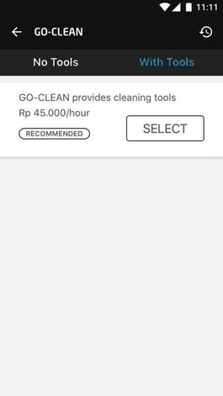 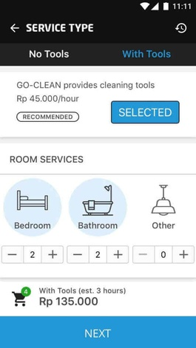 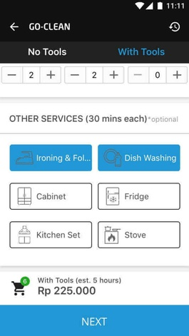

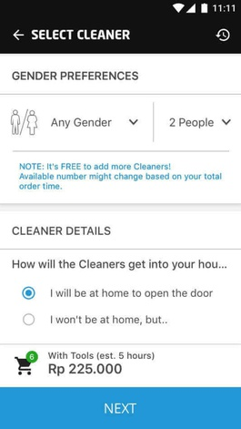 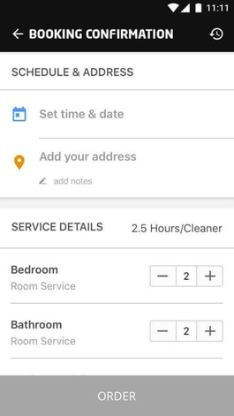 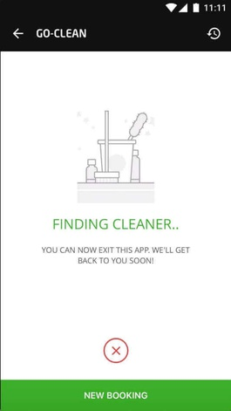

In the side of cleaners, GO-VIET will provide them with necessary tools and uniform to operate services and proper training to perform cleaning like conversation with customers or standards of cleaning. In additional to that, GO-VIET also provide a ranking system to promote cleaners with high rating.

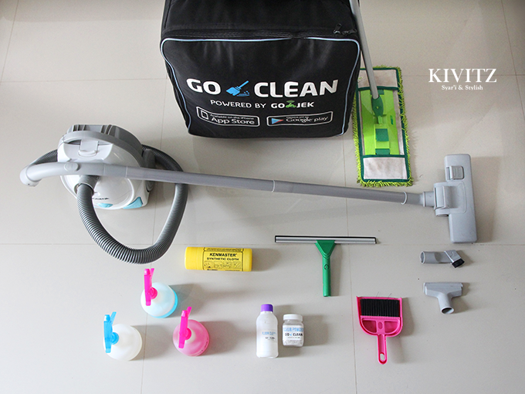

GO-CLEAN tools box

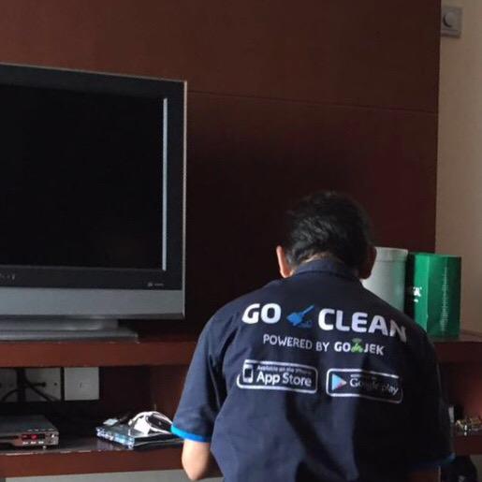

GO-CLEAN uniforms

## Why GO-CLEAN

* We have more than 700 skillful and friendly employees in cleaning field. Moreover, all of them are selected carefully and received a special training course before becoming our official staffs.
* We co-operate with the best provider in cleaning equipment in order to provide customers our professional service.
* GO-CLEAN is active 24/7. That is mean, you can call us any time you want. In addition, we work with many elite partners, so customers do not worry our service.
* We know there are many families have limit budget. However, they still want to use our service. That is why we create a list of option services which can help customers choose what they really need.

**Customer response:**

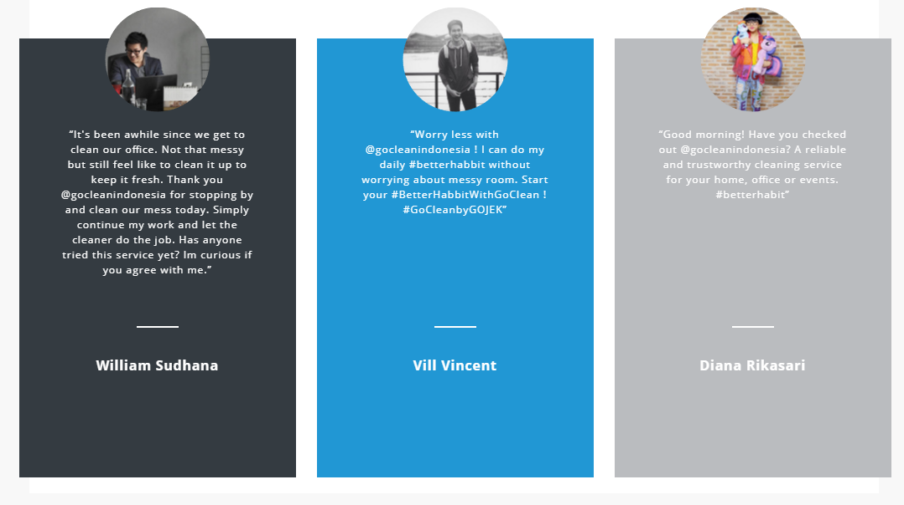

**Source :** [www.go-jek.com/go-clean](http://www.go-jek.com/go-clean)

**Our partners:**

**Pak Sugeng** :

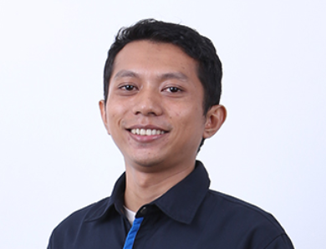

* An ex-supervisor of GO-LIFE.
* He wants to earn more money for his family. However, a full-time job will waste too much time.
* He retired from his previous job and focus on GO-CLEAN.
* He creates a connection between him and other people from various jobs.
* He can help his wife establish a food online base on his connection. From

**Nuridah** :

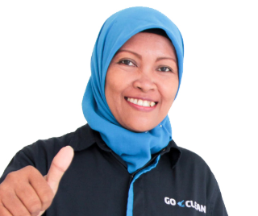

* She is a mother who truly inspire us.
* She works as a GO-JEK driver and GO-CLEAN cleaner.
* She can save enough money for her eldest child to study at the University of Indonesia.

# KEY SERVICE ELEMENTS

## Identify Market of New Services

According to the annual report and financial report in 2017, many statistics show that:

* Total numbers of household in HN and HCM city about: 3.5 million.
* About 15% household need to rent a domestic helper or housekeeper.
* Average salary of a housekeeper per hour: 40-50k VND.
* Average salary of a helper per month: 4.5 mil VND.
* In HCM city, nearly 10000 housekeepers only adapt to 30% of the market and the needs will continue increase in the future.

Those elements above contribute to create a market for building applications to hire a domestic helper that is estimated more than 1,400 billion VND-a huge mark. Thus, many suppliers housekeeper participate in this area and divide into 3 types:

* Traditional type: includes recruiting, training and providing workers.
* Half traditional type: add supporting of high technique (application) for transaction, resolve and estimate quality of services(Go-clean service)
* Only technique: link between provider and customer not provide worker directly.

## Analyze 5 key elements of Go-Clean Services

* **Resources:**
* Include all of manpower of Go-Clean service, experience knowledge and physical resource as tools for cleaning house, Go-clean tools box...
* Physical network, smartphone, the servers, SAN...
* **Provider:**
* As GO-JEK, GO-VIET will expand CLEAN service to provide better application and skillful housekeeper to their customer.
* **Consumer:**
* Employee: most of house helpers are older woman who have free time and want to become a house helper. Most of them lack experience in cleaning household and need money. Thus, they need a training course before provide workers to customer.
* Customer: who lack time to take care their house and do chores so they need a house chore worker.
* **Benefit:**
* Service provider: Go-Clean will gain benefit from 15-20% per contract between customer and employee. By satisfy the need of customer and improve service with skillful helpers»» ranking system»» increase revenue and prestige.
* Customer: Save their time from doing chores. Have more time and healthy to enjoy their life.
* Employee: Earn more money (5.5-6 mil/month) by using their free time more effective.
* **Time:**
* Typically, customer take 5-6 days to contact with employee in real life by intermediate organizations. But, with Go-Clean, customer only take a half day to meet employee directly at their home and have a week trial period before signing a contract.

**Reference:**

<https://m.bizlive.vn/noi-dung-so/app-giup-viec-nha-thi-truong-trieu-do-2246198.html>